# **CSS SYNTAX**

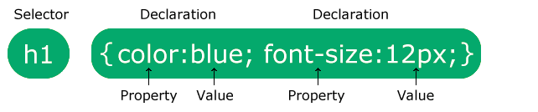

body {

background-color: lightblue;

}

h1 {

color: white;

text-align: center;

}

p {

font-family: verdana; font-size: 20px;

}

# **UNIVERSAL SELECTOR**

* {

text-align: center; color: blue;

}

# **GROUPING SELECTORS**

h1 {

text-align: center;

 h1, h2, p {

text-align: center; color: red;

}

color: red;

}

h2 {

text-align: center; color: red;

p {

text-align: center; color: red;

}

# **USING STYLES - EXTERNAL**

 <!DOCTYPE html>

<html>

<head>

<link rel="stylesheet" href="mystyle.css">

</head>

<body>

<h1>This is a heading</h1>

<p>This is a paragraph.</p>

</body>

</html>

# **INTERNAL STYLES**

 <!DOCTYPE html>

<html>

<head>

<style> body {

background-color: linen;

}

h1 {

color: maroon; margin-left: 40px;

}

</style>

</head>

<body>

<h1>This is a heading</h1>

<p>This is a paragraph.</p>

</body>

</html>

# **INLINE STYLE**

 <!DOCTYPE html>

<html>

<body>

<h1 style="color:blue;text-align:center;">This is a heading</h1>

<p style="color:red;">This is a paragraph.</p>

</body>

</html>

# **MULTIPLE STYLES**

 <head>

<link rel="stylesheet" type="text/css" href="mystyle.css">

<style> h1 {

color: orange;

}

</style>

</head>

# **CSS COLOURS**

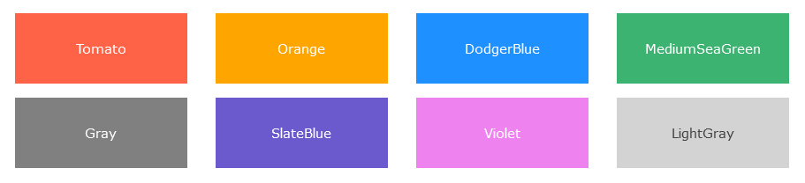

rgb(255, 99, 71)

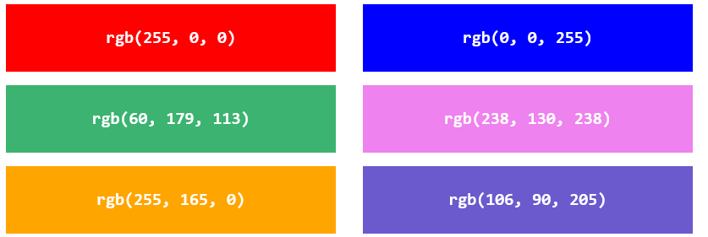

rgba(*red, green*, *blue, alpha*)



